**Matplotlib usage in the visualisation of data.**

It can be used to present the number of sales of a product, it is not suitable for big data sets as a large number of different products in the visualisation can make it hard to observe and view the data in question. On the other hand, it might be much more suitable in smaller data sets so that you can compare sales on a much smaller and more specific group of products.

**Extension –** Find a large data set and explain how the data might be visualised.

A large data set could be the classes of a country and how their wealth is divided, and it could be visualised on a pie chart into 3 modules, for example: lower, upper and middle.

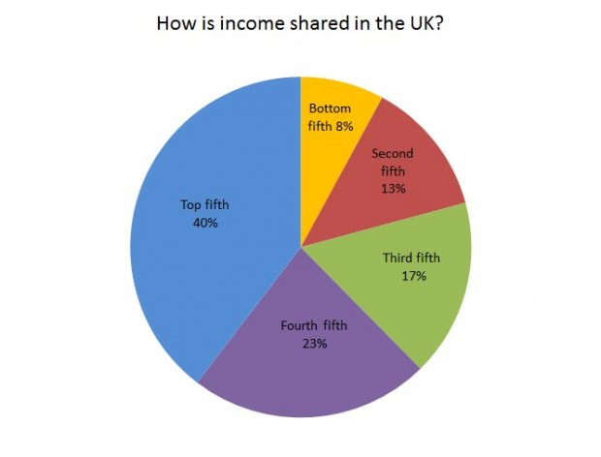

**Different example of it being used for the same reason.**